Task 9: Autonomous Steering 2

# Lab Coding

## Follow Path

Figure 2: The implemented follow_path code, following the suggested logic. I also added a check that if the agent is approaching the current waypoint, it should slow down a bit

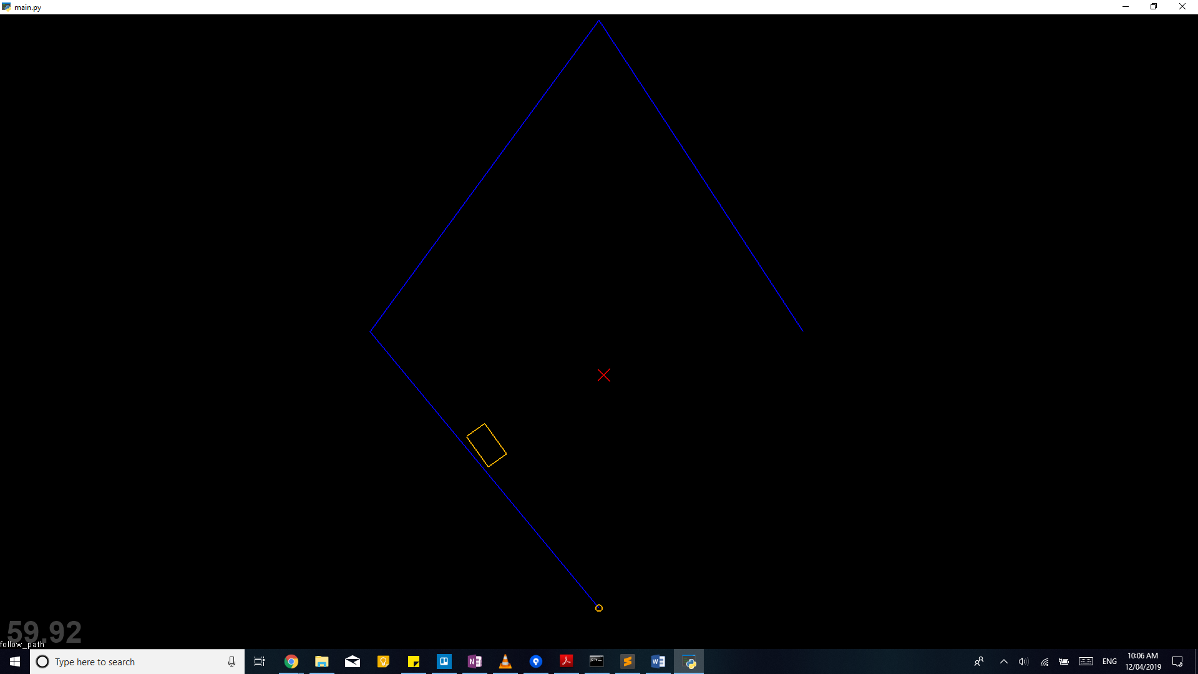

Figure 3: The code in main.py for resetting the paths of the agents.

Figure 1: The result of the follow_path code being implemented; the agent is on the last section of the path and is slowing down to arrive at the end point.

## Wander

Figure 4: The result of the wander code being implemented.

Figure 6: The flee method being tweaked so that wander is the default behaviour for fleeing agents whose hunter isn’t within their panic range.

Figure 5: I tweaked the code in the update method to impose a stricter speed limit on the wandering agents; having them racing across the screen didn’t feel right, nor did it demonstrate the wander behaviour very well.

